Batch: B2 Roll No.: 16010121200

Experiment No. 04

Grade: A / AB / BB / BC / CC / CD /DD

Signature of the Staff In-charge with date

Title: Study and implementation of Delta learning rule
Objective: To write a program to implement Delta learning rule for a given training data.
____________________________________________________________________________________
Expected Outcome of Experiment:
CO3: To Understand perceptron’s and counter propagation networks
____________________________________________________________________________________
Books/ Journals/ Websites referred:
____________________________________________________________________________________
Pre Lab/ Prior Concepts:
Delta learning rule and its application
____________________________________________________________________________________

Solved numerical example:
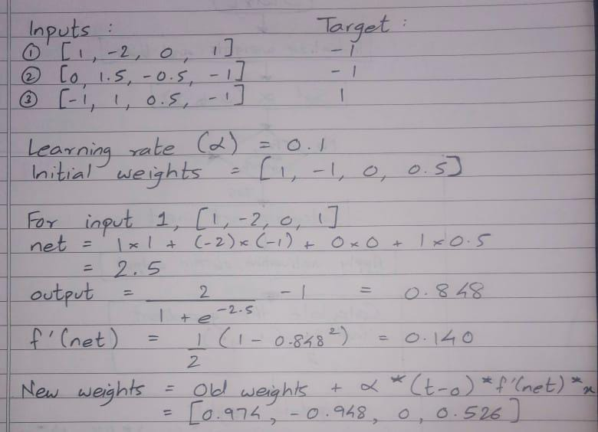
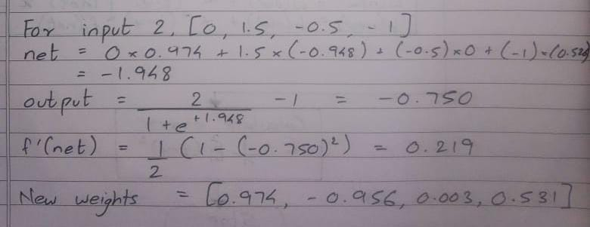
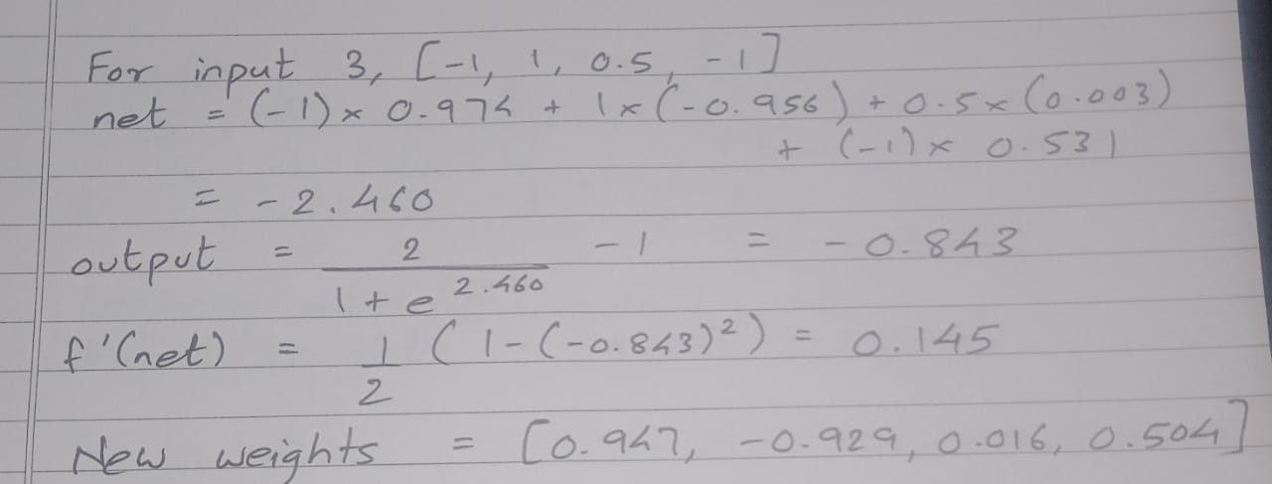

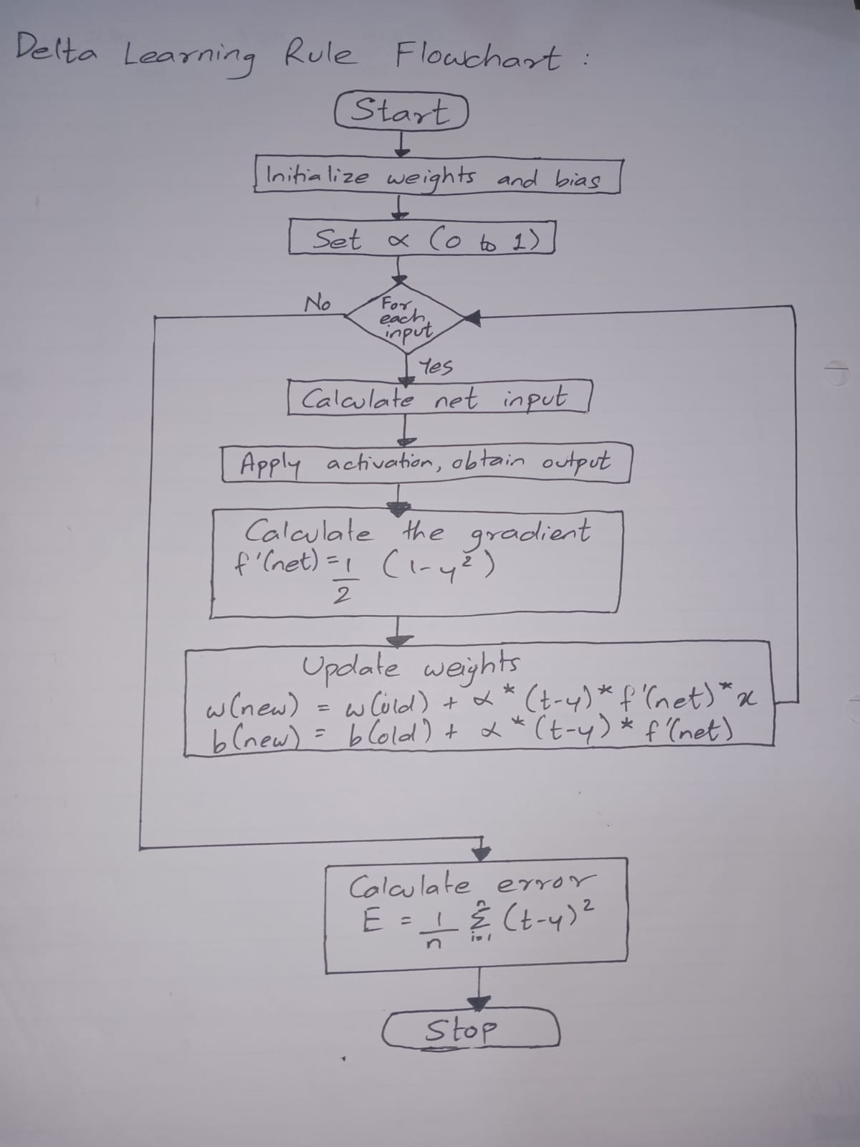

Implementation Details:
- Implement Delta learning rule for the example given in Zurada book and verify the accuracy of the result.

import numpy as np

# Activation function
def activation(net):
return 2 / (1 + np.exp(-1*net)) - 1

def deltaRule(input_vector, target):
# Initialization
lr = 0.1
weight = (1, -1, 0, 0.5)
w1, w2, w3, w4 = weight
print("Learning Rate =", lr)
print("Initial weights:\nw1 = {0}\t\tw2 = {1}\t\tw3 = {2}\t\tw4 = {3}".format(w1, w2, w3, w4))

# Delta Learning Rule
table = []
i = 0
result = [0, 0, 0, 0]
for input in input_vector:
row = []
x1, x2, x3, x4 = input
t = target[i]
net = round(x1*w1 + x2*w2 + x3*w3 + x4*w4, 3)
result[i] = net
y = round(activation(net), 3)
grad_y = round(0.5 * (1 - y**2), 3)
w1 = round(w1 + lr * (t-y) * grad_y * x1, 3)
w2 = round(w2 + lr * (t-y) * grad_y * x2, 3)
w3 = round(w3 + lr * (t-y) * grad_y * x3, 3)
w4 = round(w4 + lr * (t-y) * grad_y * x4, 3)
i += 1
row.extend([net, y, grad_y])
row.append([w1, w2, w3, w4])
table.append(row)
printTable(table)
error = 0
for i in range(len(input_vector)):
error += (1/2) * (target[i] - result[i]) ** 2
print("Error = %5.3f" % error)
return

def printTable(table):
print("----------------------------------------------------------------------------------------------------")
print("net\t\t | o\t\t\t | f'(net)\t\t | Updated weights")
print("----------------------------------------------------------------------------------------------------")
for row in table:
for value in row[:-1]:
print("%5.3f" % value, end = "\t\t | ")
print(row[-1])
print("----------------------------------------------------------------------------------------------------")

# Make a list of all inputs to be given to the network
x_1 = [1, -2, 0, -1]
x_2 = [0, 1.5, -0.5, -1]
x_3 = [-1, 1, 0.5, -1]
input_vector = []
input_vector.extend([x_1, x_2, x_3])
target = [-1, -1, 1] # Expected target outputs
deltaRule(input_vector, target) # Supply the input and expected output to the network

Output:

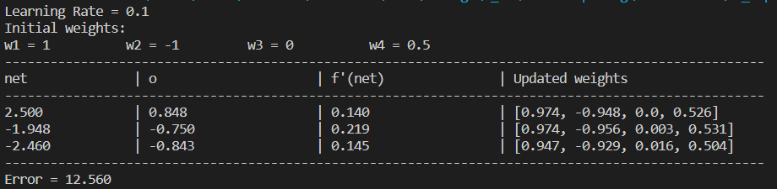

- Compute the error for different learning rate

Formula for error calculation:
$$Error= \frac{1}{n}×\sum_{i=1}^{n}{{(t-y)}^{2}}$$
When learning rate = 0.1, Error = 8.373
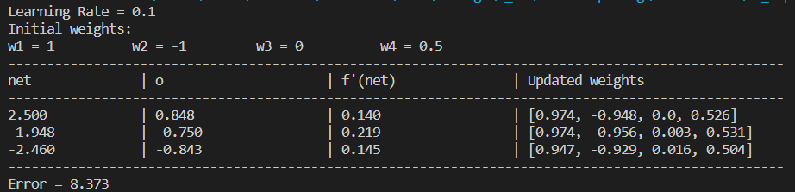

When learning rate = 0.7, Error = 7.801
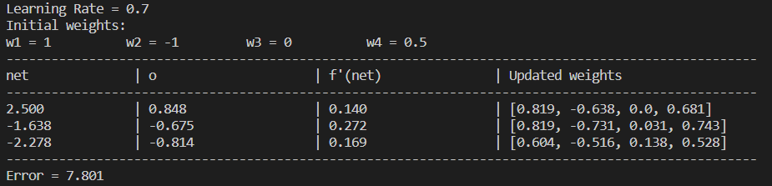

Conclusion: Thus, we have successfully implemented Delta learning algorithm of Neural Network.

Post Lab Descriptive Questions:

- Comparison of Neural network and algorithmic computation.
Neural networks have the ability to program themselves, i.e., change their processing depending on the input, while traditional algorithmic computational models follow a sequence of steps as defined in the algorithm.

- Explain different types of supervised techniques.
There are two types of Supervised Learning techniques:
- Regression: Fits the data
Regression techniques are used when the target variable is continuous, such as price, temperature, or a numerical value. The algorithm learns to predict a real-valued output based on input features.
- Classification: Separates the data
Classification techniques are used when the target variable is categorical, and the algorithm learns to assign input data points to one of several predefined classes or categories.
- Take any example and show the different steps of Delta Algorithm.




Date: 21/10/2023 Signature of faculty in-charge

